
How to sign a DocuSign document

When someone sends you a DocuSign document for your electronic signature, you first receive an email from DocuSign sent on behalf of the sender.

- Review the DocuSign email: Open the email and review the message from the sender. Click REVIEW DOCUMENT to begin the signing process.


- Agree to sign electronically: Review the consumer disclosure, and select the checkbox I agree to use Electronic Records and Signatures. Click CONTINUE to begin the signing process.
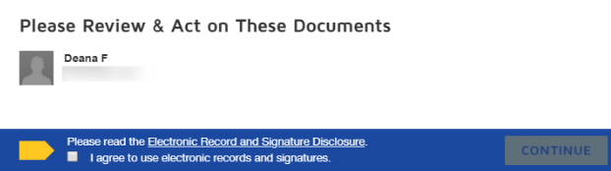

- Start the signing process: Click the START tag on the left to begin the signing process. You are taken to the first tag requiring your action.

- Click the SIGN tag. You are asked to Adopt Your Signature.
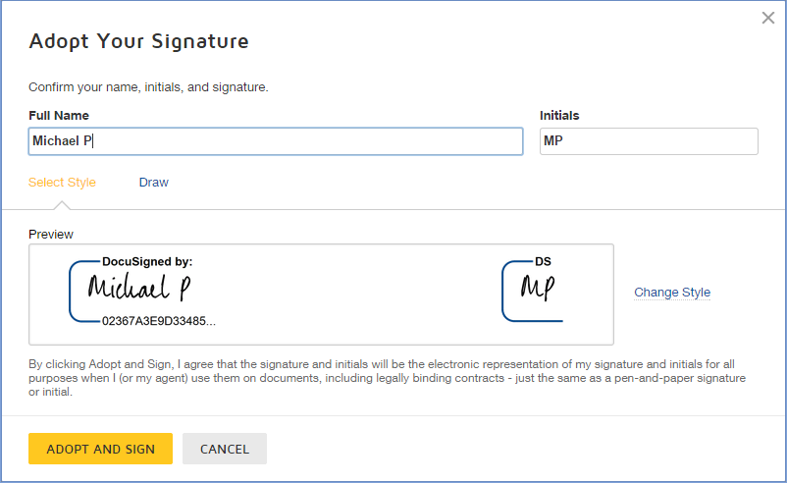

- Verify your name: Verify that your name and initials are correct. If not, change them as needed.

- Adopt a signature

- Click ADOPT AND SIGN to adopt and save your signature information and return to the document.

- Confirm signing: When you finish clicking all signature tags in the document, confirm signing by clicking FINISH. A message appears stating that you have completed your document. You can now download a PDF copy or print a copy of the document. The sender receives an email with the signed document attached, and the signed document appears in their DocuSign account

